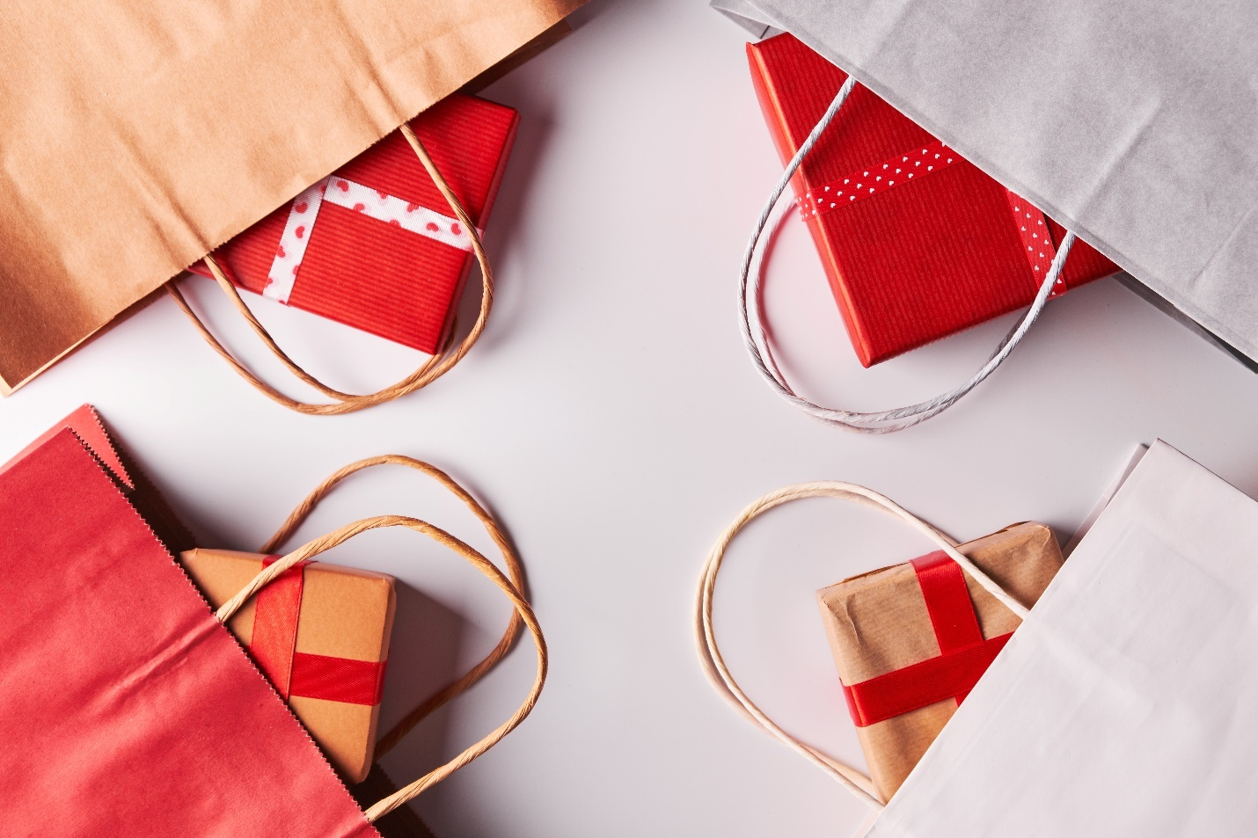
WE WOULD LIKE TO ACKNOWLEDGE AND THANK “OLD CERAMIC WAREHOUSE” AND “WENDY’S” FOR DONATING AND SPONSORING THE CHRISTMAS COLORING CONTEST. WE ALSO WOULD LIKE TO THANK THE “Loyal Order of Moose Lodge 740” FOR SPONSORING THE “MISTY LANE FARMS” HORSE AND CARRIAGE RIDES.
AS THE HOLIDAY SEASON APPROACHES, DON’T FORGET TO SHOP LOCAL AND SUPPORT OUR WONDERFUL BUSINESSES RIGHT HERE IN UHRICHSVILLE. OUR LOCAL SHOPS, RESTAURANTS, AND SERVICE PROVIDERS HAVE GONE ABOVE AND BEYOND TO GET INTO THE CHRISTMAS SPIRIT – DECORATING THEIR STOREFRONTS AND SPREADING CHEER THROUGHOUT THE COMMUNITY.

